Circuit Analysis
Lab 3
Assignment

Submitted by:
Wardah Shahid
2025-CE-81

University of Engineering
and Technology

Task1:

Circuit:
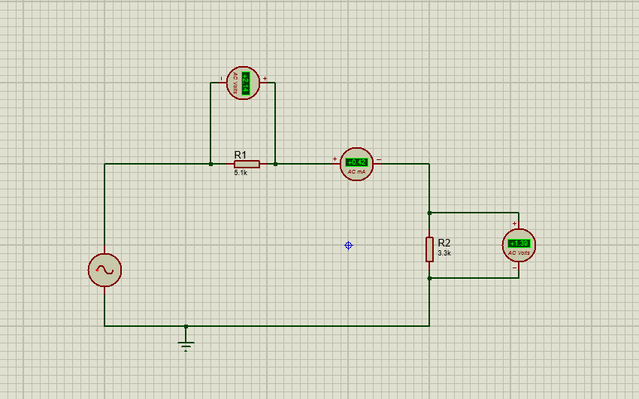

Explanation:
- An AC signal generator is used as the input source, providing a sinusoidal voltage to the circuit. The circuit is completed through a ground connection at the bottom.
- Resistor R1 (5.1 kΩ) is connected in series with the source. A voltmeter is placed across R1 to measure its voltage, which is about 2.14 V.
- An AC ammeter is connected between R1 and R2 to measure the current flowing through the circuit. The measured current is approximately 0.42 mA.
- Resistor R2 (3.3 kΩ) is connected after R1 in series. A voltmeter is connected across R2 to measure its voltage, which is about 1.39 V.
- Since both resistors are in series, the same current flows through them, and the total voltage is divided between R1 and R2 according to their resistance values.
Table:
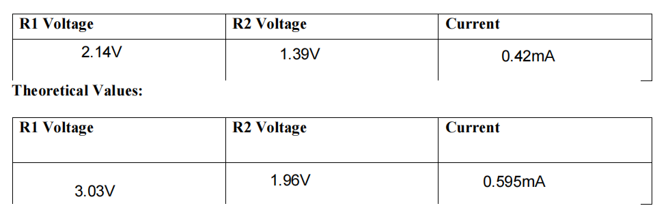

Task 2:
Circuit:
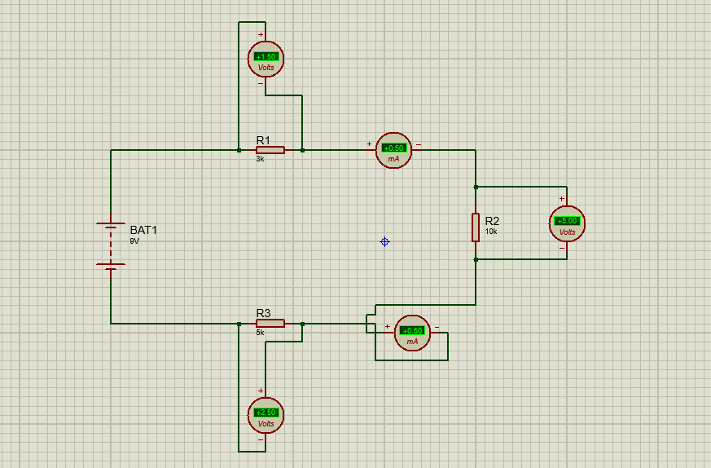

Explanation:
- This circuit is built to measure the current at node 2 and node 3 and the voltage across resistors R1, R2, and R3 using a DC source.
- A 9V battery (BAT1) is used as the power supply. Three resistors (R1, R2, R3) are connected in the circuit to form a closed loop for current flow.
- R1 (3kΩ) is connected in the upper part of the circuit. A voltmeter is placed across R1 to measure the voltage drop across it.
- R2 (1kΩ) is connected on the right side. Another voltmeter is connected across R2 to measure its voltage.
- R3 (2kΩ) is connected at the bottom part of the circuit, and a voltmeter is also placed across it.
- To measure current:
- An ammeter is placed near node 2 to measure the current flowing through that part of the circuit.
- Another ammeter is placed near node 3 to measure the current at that node.
- All components are connected properly in series so that the same current flows through each resistor, while voltmeters are connected in parallel with resistors to measure voltage correctly.
- This setup helps verify Ohm’s Law and observe how voltage is distributed across resistors and how current remains the same in a series circuit.

Table:
